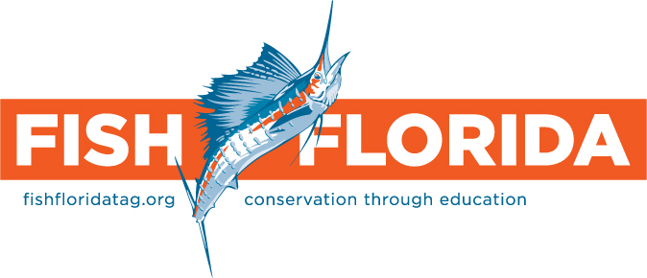

Board of Directors

President
George Poveromo
Salt Water Sportsman

Secretary/Treasurer
Bill Camp
Northern Trust

Marsha Bierman
Marsha Bierman
Enterprises

Diane Rome Peebles
Gulf Coast Graphics

Tom Putnam
Half-Hitch Tackle

Dr. Greg Tolley
Florida Gulf Coast University

Tom Twyford
West Palm Beach
Fishing Club

John Webb
Florida Sports Foundation

Dave Workman, Jr.
Strike-Zone Fishing

Fish Florida
Scott Nichols
Executive Director
3825 Investment Lane
Suite #3
WPB, FL 33404
954.927.8361
fishflorida1@gmail.com
fishfloridatag.org

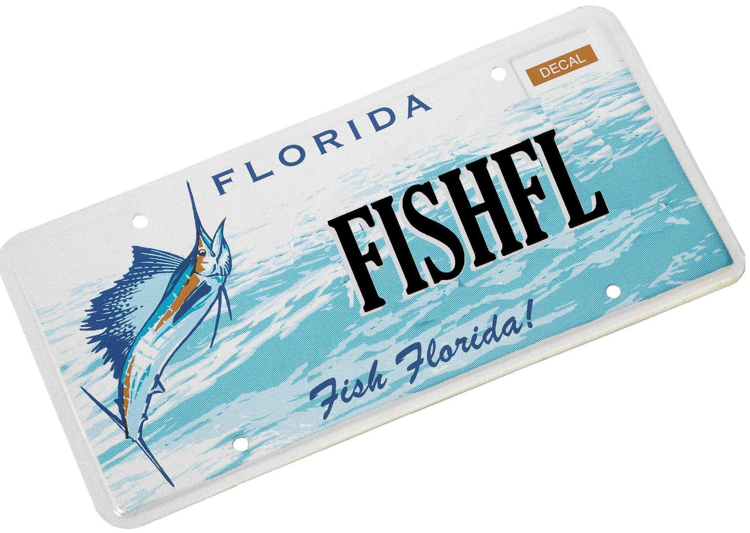

KAYE PEARSON MEMORIAL SCHOLARSHIP PROGRAM

Summary

Fish Florida is a non-profit organization whose mission is to promote public awareness of and encourage the protection of marine fisheries and coastal habitats. One or our objectives is to provide funding to groups that teach children and adults about Florida’s fish, aquatic habitats, and resource stewardship; including ethical fishing skills and ways to protect Florida’s marine environments.

Another objective is to support the aquatic sciences that increase our understanding of Florida’s waters. For Floridians to act as effective environmental stewards and to promote cooperation essential to protecting and restoring Florida’s aquatic habitats, it is necessary to have quality research. Sharing research results with children and adults gives them the knowledge to make informed choices to protect, conserve and manage Florida's aquatic resources.

Kaye Pearson, for whom our scholarship program is named, created the world’s largest boat show, the Ft. Lauderdale International Boat Show. Kaye added a kids’ fishing clinic to the show’s festivities and hundreds of children participate each year to learn the great sport of fishing. Kaye’s dedication to encouraging the next generation of anglers made him a natural fit with Fish Florida and he joined our Board of Directors on August 4, 2000. Immediately, he set to work providing advice and direction to Fish Florida. We lost Kaye to cancer in March 2009 but his contributions to Fish Florida will always live on.

General Information
- A scholarship award of up to $10,000.00 is available for registered students of Florida Gulf Coast University, Nova Southeastern University, the University of Miami and the University of South Florida,.
- Applicants should be enrolled in marine, freshwater or environmental science degree programs.
- Applicants must have a GPA of 3.0 or higher.
- All or part of a scholarship may be withdrawn if applicants fail to meet academic or other requirements.
- Applicants may apply for two successive years, based on continuing satisfactory performance. Reapplication must include a progress report.
- Awards will be disbursed to the university.

Submit with your application:
- Official transcripts (graduate and undergraduate)
- Biographical sketch explaining financial need, academic, and professional goals
- Three letters of recommendation that include character, personality, and ability testimonials and a description of your scholastic and extra-curricular activities; at least two letters must be from instructors, advisors or school officials

Application Deadline:
- June 30

Send to:
Fish Florida
Scholarship Program
3825 Investment Lane Suite #3
West Palm Beach, FL 33404

